* Default sort order direction is ascending
* **Criteria**
  + **VD1:**

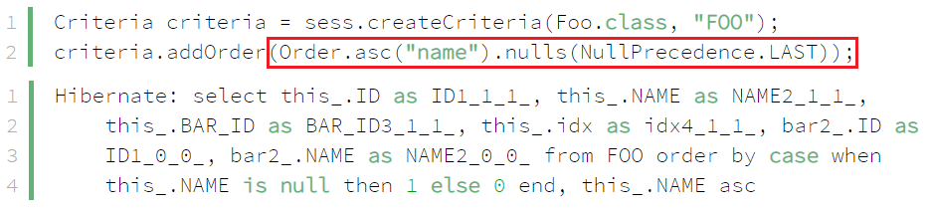

*NULLS FIRST or NULLS LAST*

* VD2:

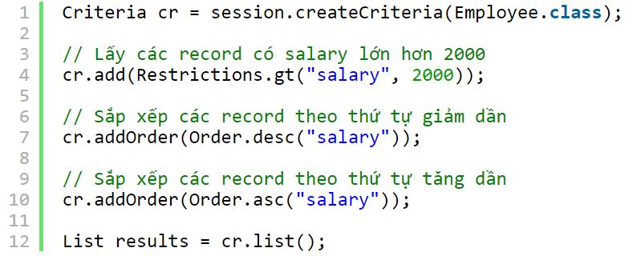

* **Reference**

<https://www.baeldung.com/hibernate-sort>